**Week 5 Microservices with Spring Boot 3 and Spring Cloud**

**Q) Creating Microservices for account and loan**

In this hands on exercises, we will create two microservices for a bank. One

microservice for handing accounts and one for handling loans.

Each microservice will be a specific independent Spring RESTful Webservice

maven project having it's own pom.xml. The only difference is that, instead of

having both account and loan as a single application, it is split into two

different applications. These webservices will be a simple service without any

backend connectivity.

**Microservice 1: Accounts Service**

**Pom.xml**

<project xmlns="http://maven.apache.org/POM/4.0.0"

xmlns:xsi="http://www.w3.org/2001/XMLSchema-instance"

xsi:schemaLocation="http://maven.apache.org/POM/4.0.0

http://maven.apache.org/xsd/maven-4.0.0.xsd">

<modelVersion>4.0.0</modelVersion>

<groupId>com.bank</groupId>

<artifactId>accounts-service</artifactId>

<version>0.0.1-SNAPSHOT</version>

<name>Accounts Service</name>

<description>Microservice for Account Handling</description>

<parent>

<groupId>org.springframework.boot</groupId>

<artifactId>spring-boot-starter-parent</artifactId>

<version>3.2.4</version>

<relativePath/>

</parent>

<dependencies>

<dependency>

<groupId>org.springframework.boot</groupId>

<artifactId>spring-boot-starter-web</artifactId>

</dependency>

</dependencies>

<build>

<plugins>

<plugin>

<groupId>org.springframework.boot</groupId>

<artifactId>spring-boot-maven-plugin</artifactId>

</plugin>

</plugins>

</build>

</project>

**AccountsServiceApplication.java**

package com.bank.accounts;

import org.springframework.boot.SpringApplication;

import org.springframework.boot.autoconfigure.SpringBootApplication;

@SpringBootApplication

public class AccountsServiceApplication {

public static void main(String[] args) {

SpringApplication.run(AccountsServiceApplication.class, args);

}

}

**AccountController.java**

package com.bank.accounts.controller;

import org.springframework.web.bind.annotation.GetMapping;

import org.springframework.web.bind.annotation.RestController;

@RestController

public class AccountController {

@GetMapping("/account/details")

public String getAccountDetails() {

return "Account details: Account Number: 123456, Type: Savings, Balance: ₹50,000";

}

}

**application.properties**

properties

Copy code

server.port=8081

**Microservice 2: Loans Service**

**pom.xml**

<project xmlns="http://maven.apache.org/POM/4.0.0"

xmlns:xsi="http://www.w3.org/2001/XMLSchema-instance"

xsi:schemaLocation="http://maven.apache.org/POM/4.0.0

http://maven.apache.org/xsd/maven-4.0.0.xsd">

<modelVersion>4.0.0</modelVersion>

<groupId>com.bank</groupId>

<artifactId>loans-service</artifactId>

<version>0.0.1-SNAPSHOT</version>

<name>Loans Service</name>

<description>Microservice for Loan Handling</description>

<parent>

<groupId>org.springframework.boot</groupId>

<artifactId>spring-boot-starter-parent</artifactId>

<version>3.2.4</version>

<relativePath/>

</parent>

<dependencies>

<dependency>

<groupId>org.springframework.boot</groupId>

<artifactId>spring-boot-starter-web</artifactId>

</dependency>

</dependencies>

<build>

<plugins>

<plugin>

<groupId>org.springframework.boot</groupId>

<artifactId>spring-boot-maven-plugin</artifactId>

</plugin>

</plugins>

</build>

</project>

**LoansServiceApplication.java**

package com.bank.loans;

import org.springframework.boot.SpringApplication;

import org.springframework.boot.autoconfigure.SpringBootApplication;

@SpringBootApplication

public class LoansServiceApplication {

public static void main(String[] args) {

SpringApplication.run(LoansServiceApplication.class, args);

}

}

**LoanController.java**

package com.bank.loans.controller;

import org.springframework.web.bind.annotation.GetMapping;

import org.springframework.web.bind.annotation.RestController;

@RestController

public class LoanController {

@GetMapping("/loan/details")

public String getLoanDetails() {

return "Loan details: Loan ID: L001, Amount: ₹2,00,000, Status: Active";

}

}

**application.properties**

server.port=8082

Account Microservice

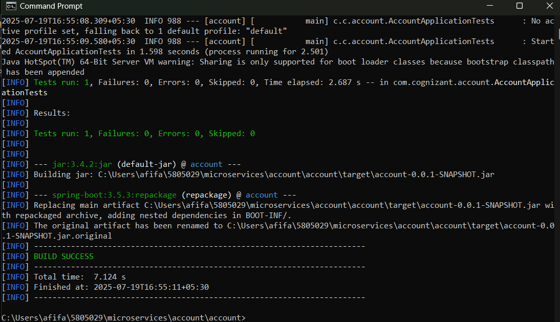

Loan Microservice

* **Account service** is running on:

http://localhost:8081/accounts/{number}

* **Loan service** is running on:

http://localhost:8082/loans/{number}

